# UBC Biology 121

# Practice Final Exam, Summer 2020

1. On the on-line exam the integrity pledge will go here (This statement is only included so that the question numbers are consistent with the Gradescope practice exam).
2. A black female mouse with normal ears is crossed with a brown male with small ears. All the F1 are black with normal ears. All the F1 are self-crossed (5 crosses) and the following F2 are obtained:

|  |
| --- |
| F2s |
| 62 black females with normal ears |
| 18 brown females with normal ears |
| 31 black males with normal ears |
| 30 black males with small ears |
| 10 brown males with normal ears |
| 9 brown males with small ears |

In the subquestions below you will determine how the traits black and brown fur and small and normal ears are inherited. (**10 marks**)

2.1 Which phenotype in ear size is dominant, if applicable? Use the space below for your work. (3 marks)

( ) normal ears

( ) small ears

( ) cannot determine based on the information

Use no more than 4 sentences, describe how you came to your decision; please include relevant information in the scenario or your reasoning to support your statement.

2.2 Identify the mode of inheritance for the ear size of mice in this scenario. Use the space below for your work. (2 marks)

( ) autosomal

( ) sex-linked

( ) cannot determine based on the information

Use no more than 4 sentences, describe how you came to your decision; please include relevant information in the scenario or your reasoning to support your statement.

2.3 Which phenotype in fur colour is dominant, if applicable? (3 marks)

() black fur

( ) brown fur

( ) cannot determine based on the information

Use no more than 4 sentences, describe how you came to your decision; please include relevant information in the scenario or your reasoning to support your statement.

2.4 Identify the mode of inheritance for the fur colour of mice in this scenario. Use the space below for work. (2 marks)

( ) autosomal

( ) sex-linked

( ) cannot determine based on the information

Use no more than 4 sentences, describe how you came to your decision; please include relevant information in the scenario or your reasoning to support your statement.

1. The Vancouver Island marmot is a large ground squirrel, related to the groundhog, that lives in burrows in high-elevation alpine meadows. It has a very limited distribution (see Figure 4) and is one of the rarest mammals in the world, with only 21 individuals in the wild as recently as 2003. Vancouver Island marmots had disappeared from about two-thirds of their historic natural range. Thanks to captive breeding and releases, the population has rebounded to over 400 individuals. Marmots mainly eat greens and many types of grasses, berries, lichens, mosses, roots, and flowers. (**10 marks total**)

* 1. List one abiotic factor that could have determined the distribution of this species and explain specifically how it could have impacted their survival or reproduction. (3 marks)
  2. List one biotic factor that could have caused their initial change in abundance and explain how it could have affected the distribution of these marmots. (3 marks)
  3. Explain how the genetics of Vancouver Island marmots could be an important factor in recovering from their population bottleneck. (4 marks)

1. Today two species of shore crab, *Hemigrapsus nudus* (the purple shore crab) and *Hemigrapsus oregonensis* (the hairy shore crab) live in the intertidal region around Vancouver. *H. nudus* is widely distributed along the west coast of North America. *H. oregonensis* is common along the coast of Oregon and Washington and its range is expanding northward. 1975 was the first time that these species could be found together on Wreck Beach. Both crab species are scavengers, consuming dead organic material, and both play a similar ecological role in the intertidal area of the marine ecosystem. In 1975 first-year Biology students did a survey of shore crab abundance at Tower Beach as a function of substratum size (e.g. on what size of rocks and pebbles were the crabs found) as seen in graph A. In 2005 another group of first-year students repeated the survey; their data are presented in graph B. (**10 marks total**)

*Hemigrapsus nudus Hemigrapsus oregonensis*

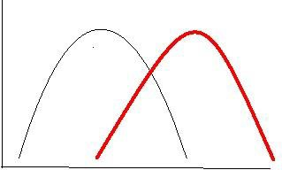Graph A: Graph B:

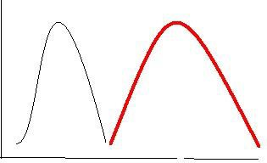No. of individuals

0 1 2 3 4 5 6 7 8 9 10 11 0 1 2 3 4 5 6 7 8 9 10 11

Size of substratum particles (cm) Size of substratum particles (cm)

Fig. 1 the relative abundance of *H. nudus* and *H. oregonensis* as a function of substratum size at Tower Beach in 1975 (Frame A) and 2005 (Frame B).

* 1. Are the curves illustrated in the graph in **graph A** examples of the fundamental or realized niches of these organisms? Explain your answer. (2 marks)
  2. What interaction (be specific) would you expect between the two species where their distribution overlaps in **graph A**? Why would you expect this interaction to occur? (3 marks)
  3. Describe the effect of this interaction on the distribution of the two species in this area over 30 years between 1975 and 2005 (**graph B**). What is the name of this ecological process (be specific)? (3 marks)
  4. List one possible characteristic of *H. oregonensis* and *H. nudus* that could have led to the results observed and indicate how this characteristic could have led to the results observed. (2 marks)

1. Point Grey, where UBC is situated, has many paths down to the beach. One of these paths, Beach trail #3, leads to Tower Beach. The cliffs surrounding the beach are made of sand and are quite unstable. In Jan. 1935, 37 cm of rain and snow fell in the Lower Mainland over four days. The subsequent flooding washed 100,000 tonnes of material down one bank above Tower Beach, forming a gulley. All soil and vegetation were swept away down the gulley. In 1965 a survey of the vegetation in the disturbed area and the adjacent undisturbed area next to the gulley was completed. (**7 marks total**)

The following plant species were found at the two sites:

|  |  |  |
| --- | --- | --- |
| Species | Number at undisturbed site | Number at disturbed site |
| Sword fern | 5 | 0 |
| Alder | 3 | 5 |
| Mature Douglas fir | 15 | 0 |
| Douglas fir seedling | 5 | 5 |
| salmonberry | 8 | 20 |
| *Mnium* (moss) | 5 | 15 |
| Maple | 3 | 0 |
| hemlock | 5 | 5 |

* 1. Which site has the greatest number of species? (1 mark)
  2. Which species is the most likely to be a pioneer species at the disturbed site? (1 mark)
  3. List two features that are characteristic of a good pioneer species. (2 marks)
  4. Compare the importance of abiotic and biotic factors in communities that are in earlier and later successional stages. Explain using examples from the data presented above. (3 marks)

1. The following species are found in a forest ecosystem: (**14 marks total**)

6.1. What are the different trophic levels represented by these species? Use a list to describe the direction of flow of energy through this community. (5 marks)

6.2 Which species would have the most biomass? Give one reason why. (2 marks)

6.3 Explain what would happen to each of the trophic levels in (a) above, if brown hares were removed from the food web. (4 marks)

6.4. In any stable community or ecosystem on Earth, large predators are rare. Use your knowledge of ecosystem ecology to explain why this might occur. (3 marks)

7. Two species of fish that live around Caribbean reefs have a unique type of interaction. The Caribbean cleaning gobies (*Elacatinus evelynae*) eat parasites (gnathiids) found on the skin of the longfin damselfish (*Stegastes diencaeus*). (**14 marks total**)

* 1. What type of interaction is occurring between these two species? (1 mark)
  2. Explain specifically how each member benefits or is harmed in this interaction. (2 marks)

7.3 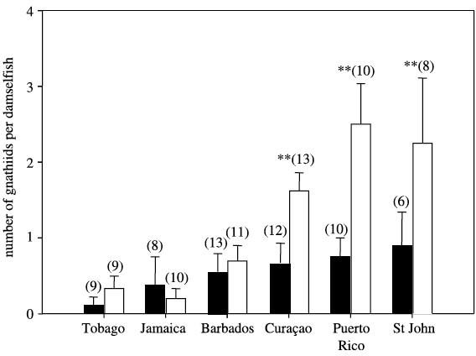Karen Cheney and Isabelle Côte studied two aspects of this interaction. First they counted the number of parasites (gnathiids) on longfin damselfish in areas with or without cleaner fish. The results are shown in Figure 1.

Figure 1. The number of gnathniids (parasites) per damselfish found at various locations in the Caribbean. Black bars indicate parasite numbers on damselfish in areas with cleaner fish. Open (white) bars indicate parasite numbers on damselfish in areas without cleaner fish. The numbers in brackets indicate the

sample size. The stars (**) indicate where the number of parasites on damselfish significantly differed between treatments (cleaner fish present, cleaner fish absent).

Describe the results shown in Figure 1 above. (2 marks)

7.4 What can you conclude from this graph about the effect of cleaner fish on the number of parasites found on damselfish. (2 marks)

* 1. How would you describe the type of interaction where the cleaner fish eats more scales, mucus and tissue from the damselfish than parasites? (1 mark)
  2. Explain specifically how each member benefits or is harmed in the interaction described in 7.5). (2 marks)

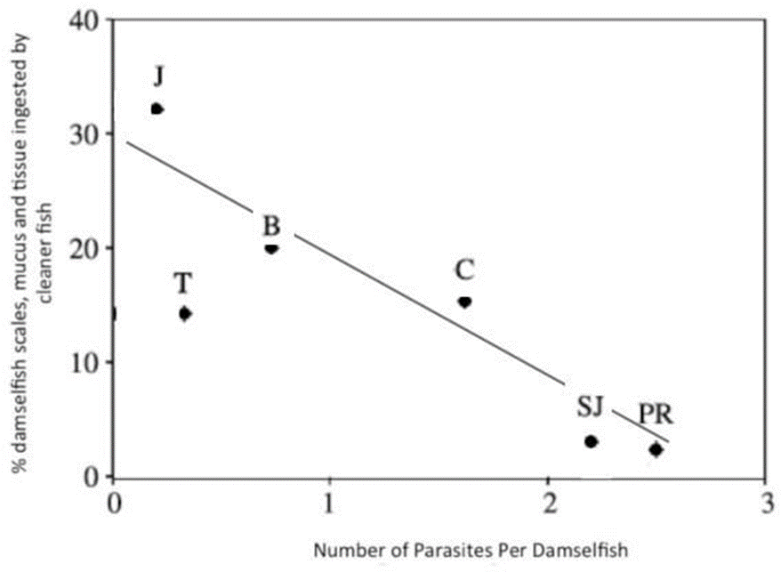

Figure 2. The % of damselfish material ingested when compared with the number of parasites on the damselfish. Vertical and horizontal lines show the amount of variation in the data.

* 1. Describe the results shown in Figure 2 above. (2 marks)
  2. How do parasite numbers on damselfish change the interaction between cleaner fish and damselfish? (2 marks)

1. *Tetrahymena* are unicellular eukaryotic ciliates (not photosynthetic) that are easily grown in a flask in the lab containing a standard liquid medium that consists of all the nutrients they require. Under optimum conditions it takes 2 hours for the cells to grow and divide. If cell number is graphed against time the following curve is obtained (Figure 3): (**12 marks total**)



**Time (generations)**

**9 10 11 12**

**8**

**7**

**6**

**5**

**4**

**3**

**2**

**1**

**450**

**400**

**350**

**300**

**250**

**200**

**150**

**100**

**50**

**0**

Figure 3. The number of *Tetrahymena* (cells per mL) over time.

* 1. What is the carrying capacity of this flask for *Tetrahymena*? (1 mark)
  2. How do birth rate and death rate compare to each other at these time points? (3 marks)

1. Generation 2-3:
2. Generation 5-6:
3. Generation 11-12:
   1. Describe how the number of individuals changes through time (3 marks)

8 You are interested in identifying the impact of high amounts of heavy metals on *Tetrahymena*. You decide to conduct an experiment to assess the impact of copper (Cu2+) on *Tetrahymena* growth. You measure growth of 2 populations of *Tetrahymena*: one population is incubated in Cu2+ (100 mg/L), the other has no Cu2+ added (control). Your results are depicted in Figure 4 below:

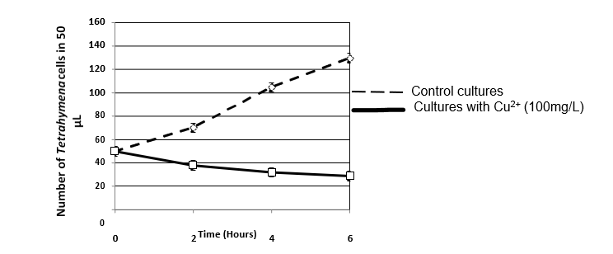

Figure 4: Mean number of *Tetrahymena* cells plotted against time for two populations: one control (dashed line) and one treated with Cu2+ (100 mg/L; solid line). N=3 measurements of cell number per time point. Error bars are 95% confidence intervals.

8.4 What effect has Cu2+ had on the growth of *Tetrahymena*? (1 mark)

8.5 You leave the lab at the end of the day (time 6 in Figure 4), and when you come in the next morning, you count the number of cells in a 50 µL sample. You data are shown below:

|  |  |  |
| --- | --- | --- |
|  | **Number of *Tetrahymena* in 50 µL the next morning.** | |
|  | **Control cultures (standard medium)** | **Experimental cultures (standard medium + 100 mg/L Cu2+)** |
| **Mean of 3 replicates** | 1050 | 433 |

What has happened to the *Tetrahymena* population in the experimental (Cu2+containing) cultures that has allowed its numbers to increase from

~30 to 433 cells/50µL? (4 marks)

1. The white-handed gibbon (*Hylobates lar*) is a kind of ape that lives in South-East Asia. Suppose the length of their adult arms is either long (over 0.5m) or short (less than 0.5m) and this trait is controlled by two alleles of a single gene. (13 marks total)
   1. The allele for long arms (*A1*) is dominant to the allele for short arms (*A2*). In a population of 100 apes, 49 had short arms. Assume the Hardy-Weinberg (HW) equilibrium is in effect and calculate *p* for the long *A1* allele and *q* for the short *A2* allele. No need to show your work in Gradescope. (3 marks)
   2. What is the frequency of long-armed heterozygous individuals in this population? Show all your work. (2 marks)
   3. **Scenario text copied for reference:** The white-handed gibbon (*Hylobates lar*) is a kind of ape that lives in South-East Asia. Suppose the length of their adult arms is either long (over 0.5m) or short (less than 0.5m) and this trait is controlled by two alleles of a single gene. (13 marks total)

In subquestion 9.1 above you were told to assume the HW equilibrium is in effect. Is this a reasonable assumption in this example? Explain two reasons why it is or isn’t. (4 marks)

* 1. 'A1' is the dominant allele for the production of arm length and 'B1' is the dominant allele for the production of dark fur. The two genes in question are on different chromosomes. A male gibbon who is heterozygous (A1/A2; B1/B2) for both genes produces a sperm cell with the nucleus shown below. The locus for each allele is marked on the appropriate chromosome.

Which of the student drawings below (a through d) shows the chromosomes of the pre-gamete cell that produced the sperm shown above in Metaphase I of meiosis? Briefly explain your response. (2 marks)

* 1. If you sampled many sperm from this male gibbon, what would the expected genotypes and genotypic ratio of the combinations of these two genes be? (2 marks)